Task #1:

#include<iostream>

#include<ctime>

#include<cmath>

using namespace std;

int main()

{

cout << abs(-4) << endl;//absolute function will give postive value//

cout << fabs(10.8) << endl;;//This function return absolute value of its arguments but its argument is postive it will return same//

cout << fabs(-2.5) << endl;; // This function return absolute value of its arguments//

cout << pow(3.2, 2) << endl;;//This Function will Take Power of two arguments //

cout << pow(2.5, 3) << endl;;//This Function will also take Power of two arguments//

cout << sqrt(25.0) << endl;;//This function Takes square root of function//

cout<<sqrt(6.25) << endl;;//This function Takes square root of function//

cout << pow(3.0, 4.0) / abs(-9) << endl;;//This function will also Take power but we are dividing with the absolute function//

cout << floor(28.95) << endl;;//return the Largest whole Number That is not greater than its arguments or x //

cout << ceil(35.2) << endl;;//return the smallest whole Number that is not less than its arguments//

system("pause");

return 0;

}

Output:

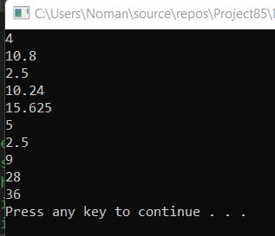

Task #2:

#include<iostream>

using namespace std;

int average(int num)

{

if (num >= 90 && num < 100)//These are Following conditions for differnts Grades //

{

return 4;

}

if (num >= 80 && num < 90)//This Line will return 3//

{

return 3;

}

if (num>=70&&num<80)//This Line will return 2//

{

return 2;

}

if (num >=60 && num < 70)//This Line will return 1//

{

return 1;

}

if (num < 60)//This Line will return 0//

{

return 0;

}

}

int main()

{

int num;

cout << "Enter the average of student ";//taking Average of student//

cin >> num;

cout << "This is the Grade " << average(num) << endl;//Calling Fuction and displaying that grades //

system("pause");

}

Output:

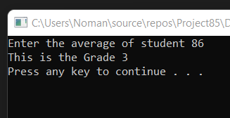

Task #3:

#include <iostream>

using namespace std;

void addFirst(int& first, int& second);//The Name of function is addfirst and in this we are passing arguments with reference parameters //

void doubleFirst(int one, int two);//simply we are passing two argumens and name of Function is double first//

void squareFirst(int& ref, int val);//In this only one argument is passing by reference//

int main()

{

int num = 5;

cout << "Line 1: Inside main: num = " << num<< endl; //Line 1 displaying the value of num which is =5//

addFirst(num, num); //Line 2

cout << "Line 3: Inside main after addFirst:"<< " num = " << num << endl; //Line 3 inside main after add num is =14//

doubleFirst(num, num); //Line 4 these two arguments have same value which is eqaul to 14//

cout << "Line 5: Inside main after "

<< "doubleFirst: num = " << num << endl; //Line 5

squareFirst(num, num); //Line 6

cout << "Line 7: Inside main after " << "squareFirst: num = " << num << endl; //Line 7

return 0;

}

void addFirst(int& first, int& second)//In this Function we are using passing Refrence parameters //

{

cout << "Line 8: Inside addFirst: first = "

<< first << ", second = " << second << endl; //Line 8

first = first + 2; //Line 9

cout << "Line 10: Inside addFirst: first = "

<< first << ", second = " << second << endl; //Line 10

second = second * 2; //Line 11

cout << "Line 12: Inside addFirst: first = "<< first << ", second = " << second << endl; //Line 12

}

void doubleFirst(int one, int two)

{

cout << "Line 13: Inside doubleFirst: one = "

<< one << ", two = " << two << endl; //Line 13

one = one * 2; //Line 14

cout << "Line 15: Inside doubleFirst: one = "

<< one << ", two = " << two << endl; //Line 15

two = two + 2; //Line 16

cout << "Line 17: Inside doubleFirst: one = "

<< one << ", two = " << two << endl; //Line 17

}

void squareFirst(int& ref, int val)

{

cout << "Line 18: Inside squareFirst: ref = "

<< ref << ", val = " << val << endl; //Line 18

ref = ref * ref; //Line 19

cout << "Line 20: Inside squareFirst: ref = "

<< ref << ", val = " << val << endl; //Line 20

val = val + 2; //Line 21

cout << "Line 22: Inside squareFirst: ref = "

<< ref << ", val = " << val << endl; //Line 22

system("pause");

}

Output:

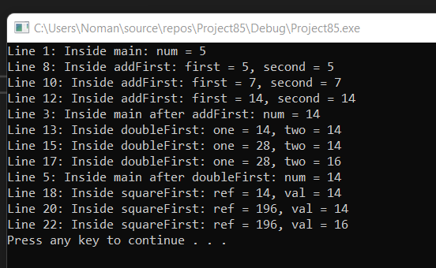

Task #4:

#include<iostream>

using namespace std;

int sum(int num1, int num2)//Making First function for sum//

{

int add;

add = num1 + num2;

return add;

}

float sum(float num1, float num2)//Making second function for sum//

{

float add;

add = num1 + num2;

return add;//return add//

}

int sum(int a, int b, int c)//Making Third function for sum//

{

int add;

add = a + b + c;

return add;

}

int main()

{

int num1, num2,a,b,c;//declaring some variables//

int choice;

float n1, n2;

cout << "Enter your choice between one and three :" << endl;//taking input//

cin >> choice;

if (choice==1)//These are Differnts choices for User//

{

cout << "Enter the First number ";

cin >> num1;

cout << "Enter the second Number : ";

cin >> num2;

cout <<"The sum is "<< sum(num1, num2);//Calling the Function or we can also Give numbers in actual parameters //

}

if (choice==2)

{

cout << "Enter the two numbers in float ";

cin >> n1 >> n2;

cout << "The sum is :"<<sum(n1, n2) << endl;//calling function//

}

if (choice==3)

{

cout << "Enter the three numbers ";

cin >> a >> b >> c;

cout<<"The sum is"<<sum(a, b, c)<<endl;//calling function//

}

system("pause");

return 0;

}

Output:

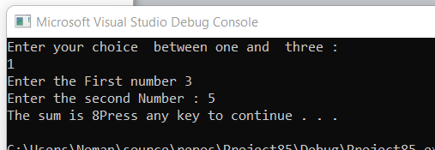

Task #5:

#include<iostream>

using namespace std;

int sum(int num1, int num2,int num3,int num4)//Making First function for sum//

{

int add;

add = num1 + num2+num3+num4;

return add;

}

int main()

{

int num1 = 0, num2 = 0, num3 = 0, num4 = 0, flag = 1, input, count = 1;//declaring some variables//

cout << "If we input 0 then it will terminate " << endl;

while (flag!=0)

{

cout << "Enter an integer = ";

cin >> input;

if (input == 0)//These are differnt conditions //

{

flag = 0;

}

else

{

if (count == 1)

{

num1 = input;

}

else {

if (count == 2)

{

num2 = input;

}

else

{

if (count == 3)

{

num3 = input;

}

else

{

if (count == 4)

{

num4 = input;

flag = 0;

}

}

}

}

count++;

}

}

cout << "sum =" << sum(num1, num2, num3, num4) << endl;

system("pause");

return 0;

}

Output:

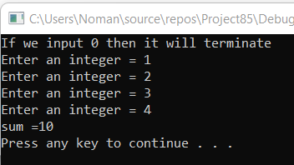

**Task #8:**

#include <iostream>

#include <iomanip>

using namespace std;

int volume(int l = 1, int w = 1, int h = 1);

void funcOne(int& x, double y = 12.34, char z = 'B');

int main()

{

int a = 23;

double b = 48.78;

char ch = 'M';

cout << fixed << showpoint;

cout << setprecision(2);

cout << "Line 1: a = " << a << ", b = "

<< b << ", ch = " << ch << endl; //Line 1

cout << "Line 2: Volume = " << volume()//?

<< endl; //Line 2

cout << "Line 3: Volume = " << volume(5.4, 4)//?

<< endl; //Line 3

cout << "Line 4: Volume = " << volume('A')//?

<< endl; //Line 4

cout << "Line 5: Volume = "

<< volume(6, 4, 5) << endl; //?

funcOne(a); //?

funcOne(a, 42.68, 1); //?

funcOne(a, 34.65, 'Q'); //?

cout << "Line 9: a = " << a << ", b = "

<< b << ", ch = " << ch << endl; //Line 9

return 0;

}

int volume(int l, int w, int h)

{

return l * w * h; //Line 10

}

void funcOne(int& x, double y, char z)

{

x = 2 * x; //Line 11

cout << "Line 12: x = " << x << ", y = "

<< y << ;

}